Types of Binary Tree
There’re mainly 4 types of Binary Tree.
1. Full Binary Tree
2. Complete Binary Tree
3. Perfect Binary Tree
4. Balanced Binary Tree
5. Pathological Binary Tree
1. Full Binary Tree: In Full Binary Tree, every node has either 2 or 0 child nodes. Leaf node will have zero and it is valid.
2. Complete Binary Tree:
a. Every node should have 2 child nodes except last level.
b. If it is a last level, then child nodes should start from left.
c. We cannot break the left to right pattern in the last level.
d. Means while moving from left to right, we filled 2 positions, left 3 and 4 and then again filled 5, 6. Then this is not a complete Binary Tree
3. Perfect Binary Tree: If all the internal nodes have exactly 2 children and all the leaf nodes are present in the same level, the tree is called a Perfect Binary Tree.
4. Balanced Binary Tree:
Formula: |Height of Left Subtree – Height of Right Subtree|
If the difference is 0 or 1 for every node, it is balanced.
5. Pathological Binary Tree: When every parent node has only one child node.

Full Binary Tree
Example 1
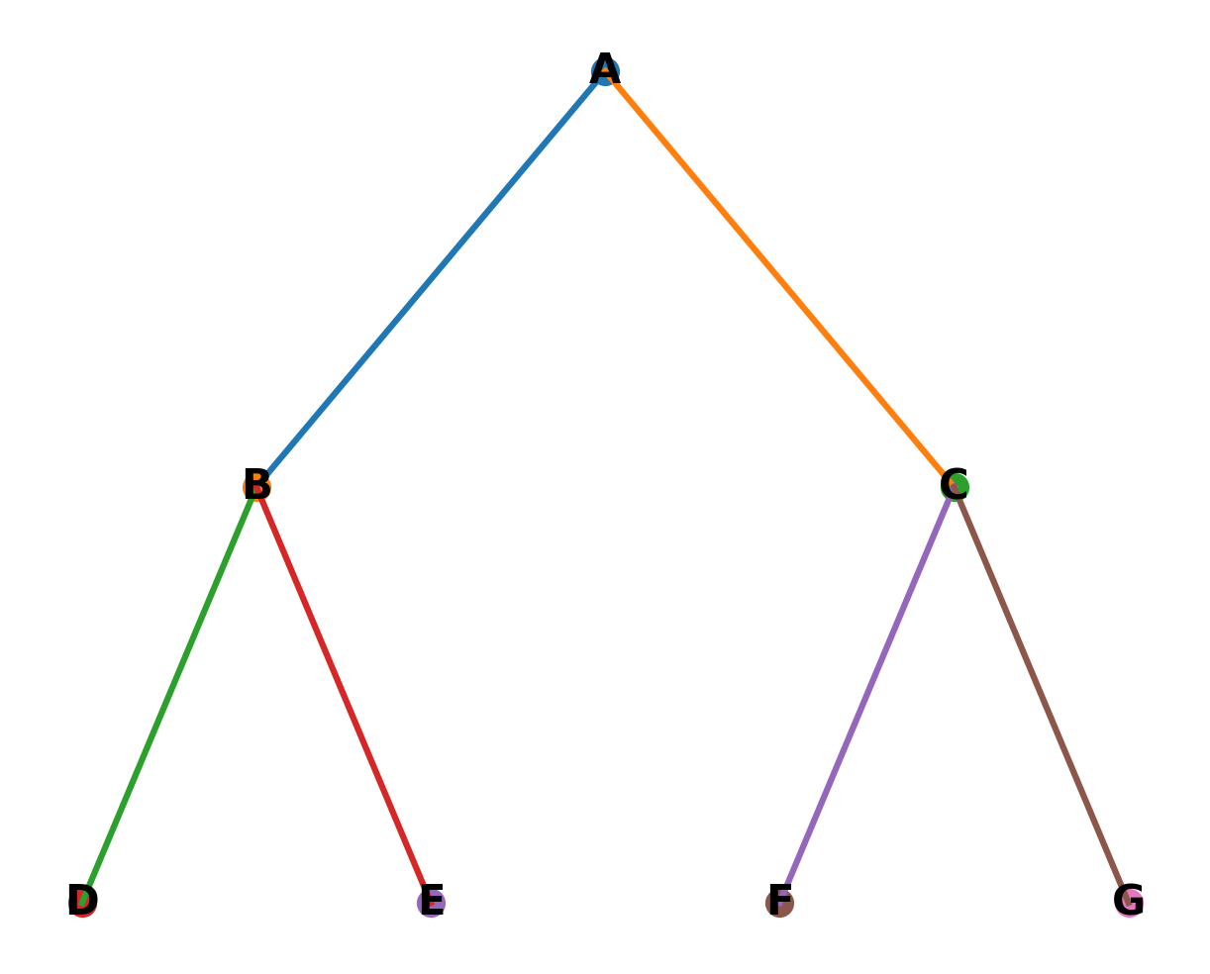
Example 2
Example 3
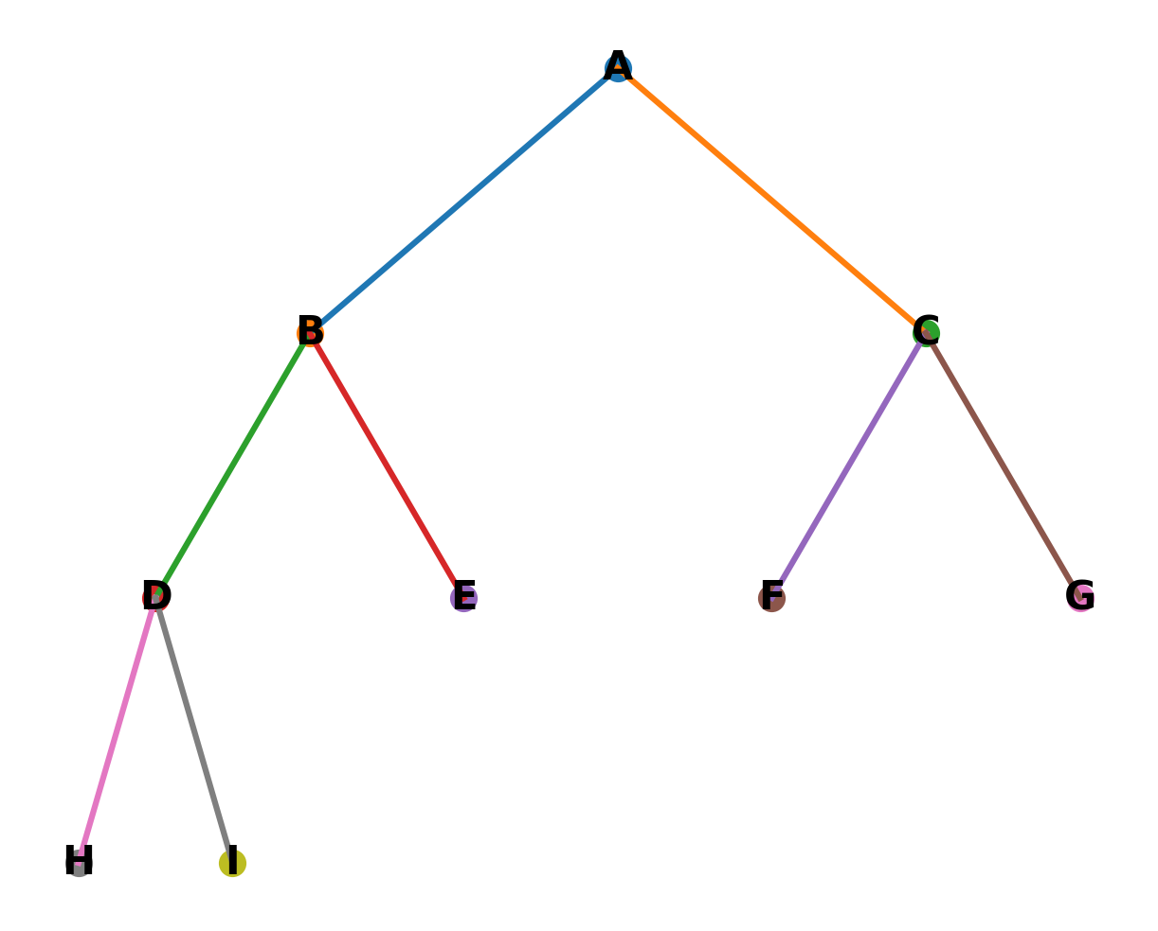
Example 4
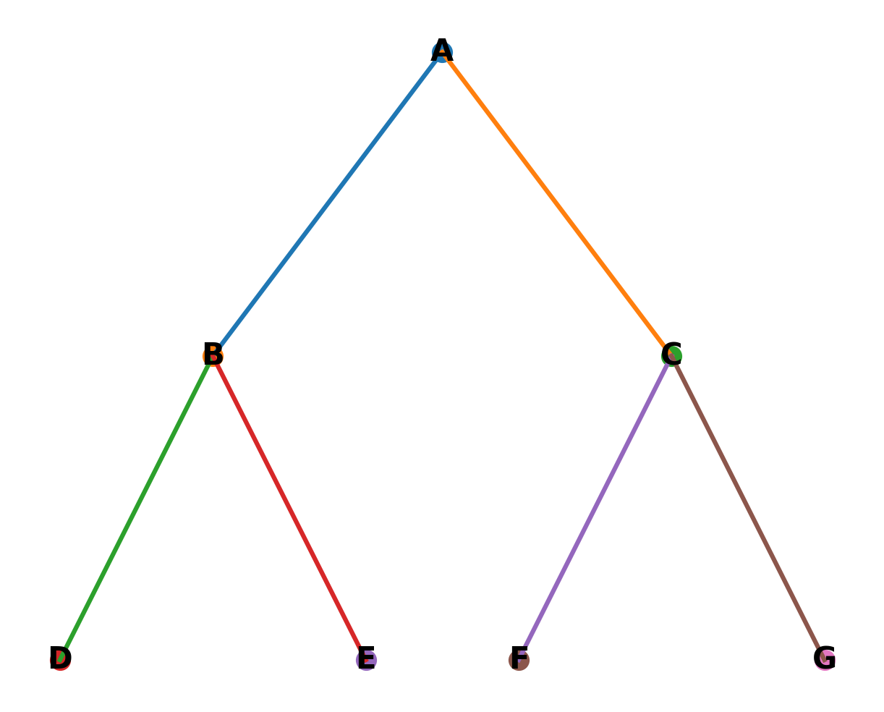

Example 5

Pathological Binary Tree
Example 1
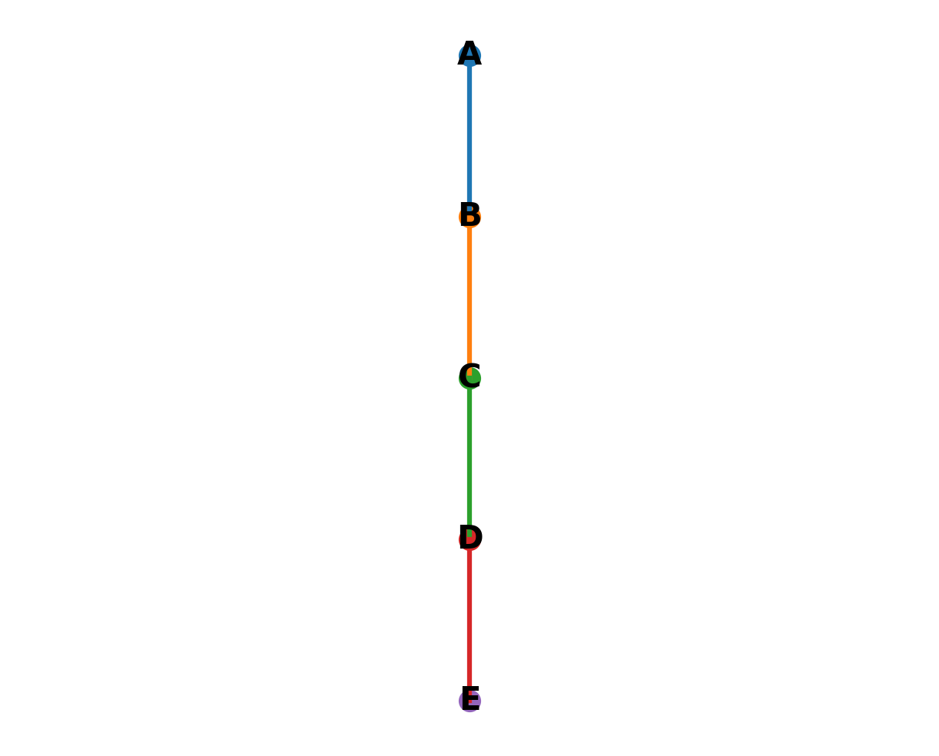
Example 2
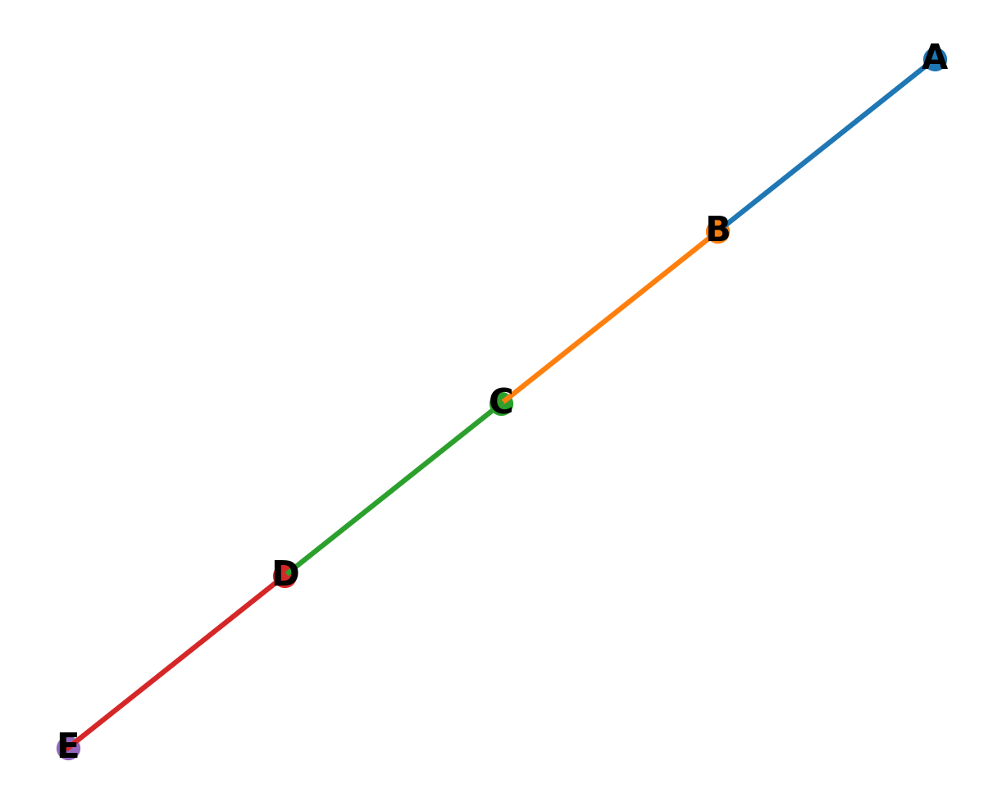
Example 3
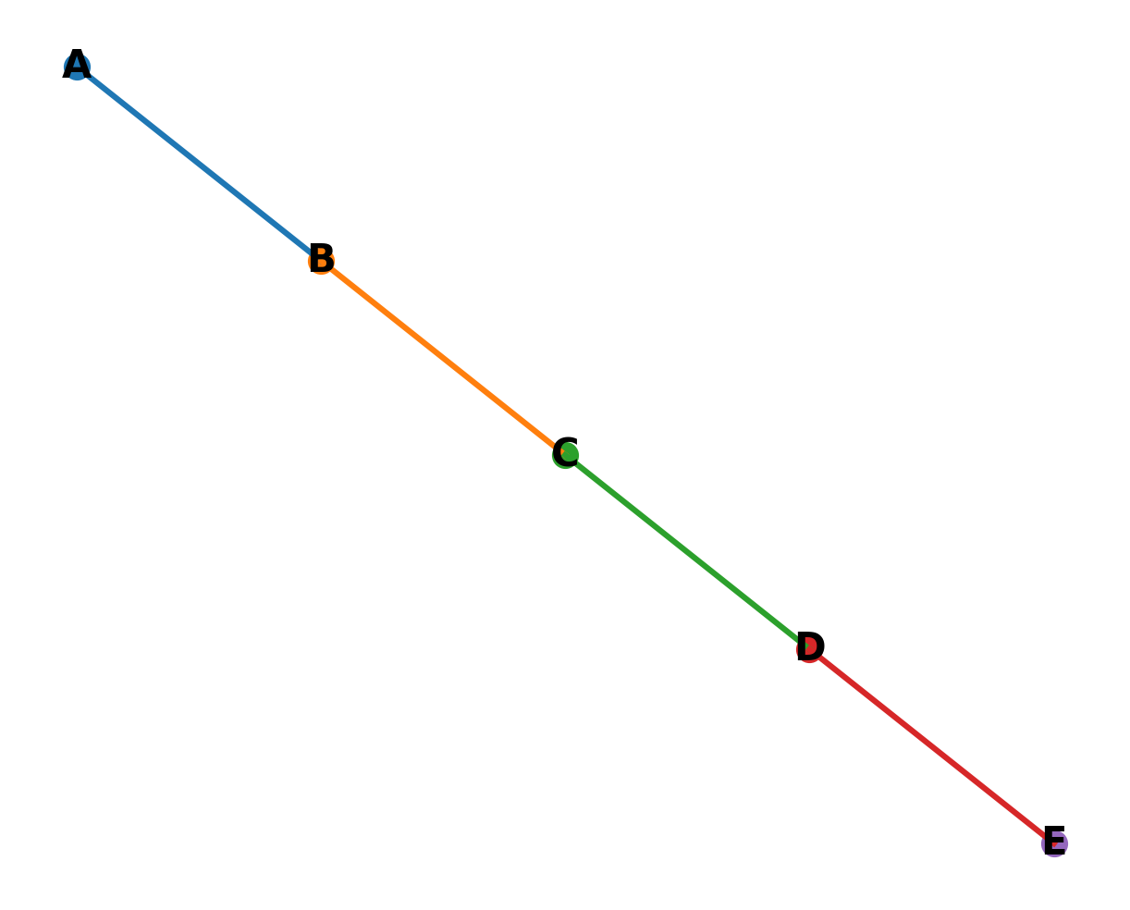
Example 4
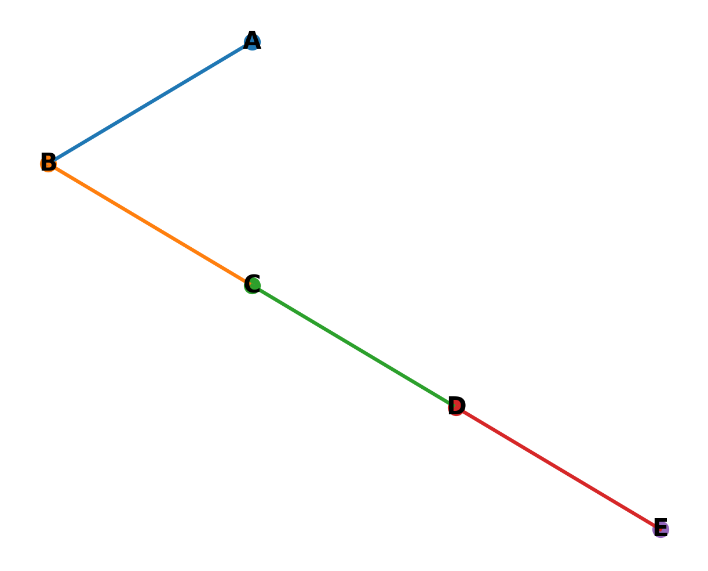
Example 5
